ANALOG -TO- DIGITAL CONVERTOR (ADC)

Learning objectives

1. **Understanding Analog vs. Digital Signals**:

Explain the difference between analog and digital signals.

Illustrate the concept of analog-to-digital conversion.

**2.Assessing ADC Quality**:

Evaluate the quality of analog-to-digital conversion using the following metrics

1.Sampling rate

2.Quantization levels

3.Number of bits used for encoding

4.Dynamic range.

INPUTS

The input data from the ADC is read through the P1 port of the 8051 microcontroller. This means that P1 serves as the input port for the ADC data.

OUTPUTS

* The converted digital data (output from the ADC) is sent to the P3 port of the 8051 microcontroller. Specifically:
  + P3.0 (bit 0) corresponds to the least significant bit (LSB) of the ADC output.
  + P3.1 (bit 1) corresponds to the next bit.
  + P3.2 (bit 2) corresponds to the next bit
  + P3.3 (bit 3) corresponds to the most significant bit (MSB) of the ADC output.

LOGIC

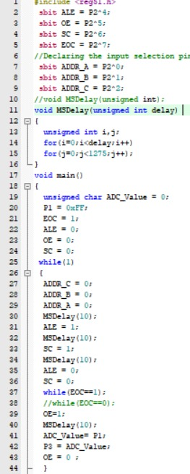

RESULT

an ADC transforms continuous-time and continuous-amplitude analog signals into discrete-time and discrete-amplitude digital signals, allowing us to process and manipulate them digitally.